Lulu Brannan
Professor Negron
PLN4030-101
24 September 2025

Community Climate Profile: Juneau, Alaska
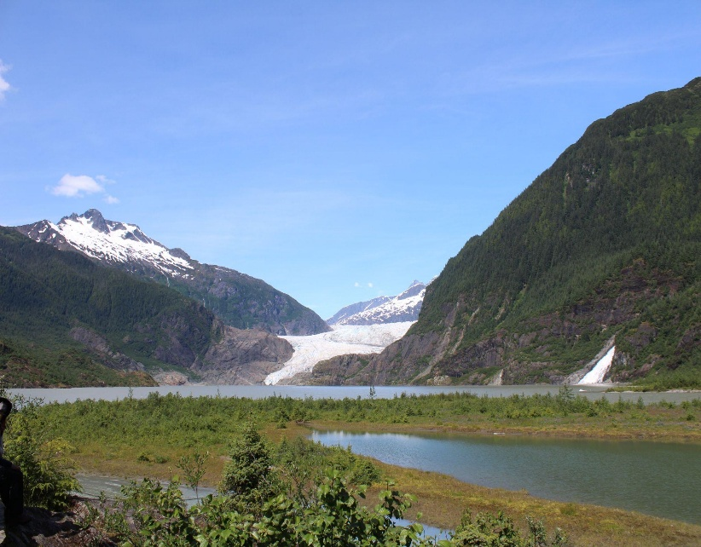
Juneau, the capital of Alaska, is the largest city in Southeast Alaska, with a population of thirty-two thousand residents. Hidden in the inside passage, only accessible by water or air, the town of Juneau grew to be known as “The City Built on Gold.” Juneau founded one of the largest gold mines in the world and is one of the most unique capitals in the U.S. Juneau’s present government solely relies on fisheries, hydropower, and tourism, all susceptible to climate change.
Juneau is home to the Mendenhall Glacier, which means it faces significant risks of glacial retreat, which then turns into flooding. Alaska is also warming faster than most places on earth right now, with statewide average temperatures rising two to three times faster than the global means (USDA Climate Hubs, 2023). The Arctic is experiencing even faster warming, about three to four times faster than the rest of the world (Rantanen et al., 2022). This paper will talk about Juneau’s climate vulnerability, risks, current and projected climate trends, and existing policies and responses.
Mendenhall Glacier: Photo by Lulu Brannan, 2025

Climate Analysis
Juneau sits in the heart of the Tongass National Forest, the largest temperate rainforest in the world. The Tongass National Forest gets around 100-200 inches a year, due to the moist Pacific air lifting over the mountains, cooling, and producing constant cloud cover, fog, and heavy precipitation. Because the climate is getting warmer, more of the winter precipitation in Juneau falls as rain instead of snow. This means snow does not last as long on the ground. Snow in Alaska is much different then snow in any other region in the U.S. Snow in Alaska acts like a reservoir, slowly releasing water into streams and rivers as it melts. When there is less snow, water runs out quicker, leaving less available in the summer, when it is needed the most.
Scientists measure this using something called Snow Water Equivalent (SWE). By the middle of this century, areas below 820 feet in elevation could see snowpack levels drop by as much as 44% (USDA Climate Hubs, 2023).
Another major sign of climate change is the Mendenhall glacier retreat. Mendenhall is one of the most visited glaciers in North America and has shrunk about 1.75 miles since 1929 (USDA Climate Hubs, 2023). As Mendenhall continues to melt, it forms lakes held in place by ice, almost acting like a dam. These lakes are deemed unstable due to the uncertainty of when the ice will break, causing a sudden release of water called GLOF (glacial outburst flooding). This problem is already visible in Juneau, where Suicide Basin, a side basin connected to Mendenhall Glacier, has triggered nearly annual GLOFs since 2011 (USGS, 2025). These floods pour into the Mendenhall River, damaging homes, eroding riverbanks, and forcing evacuations in nearby neighborhoods.
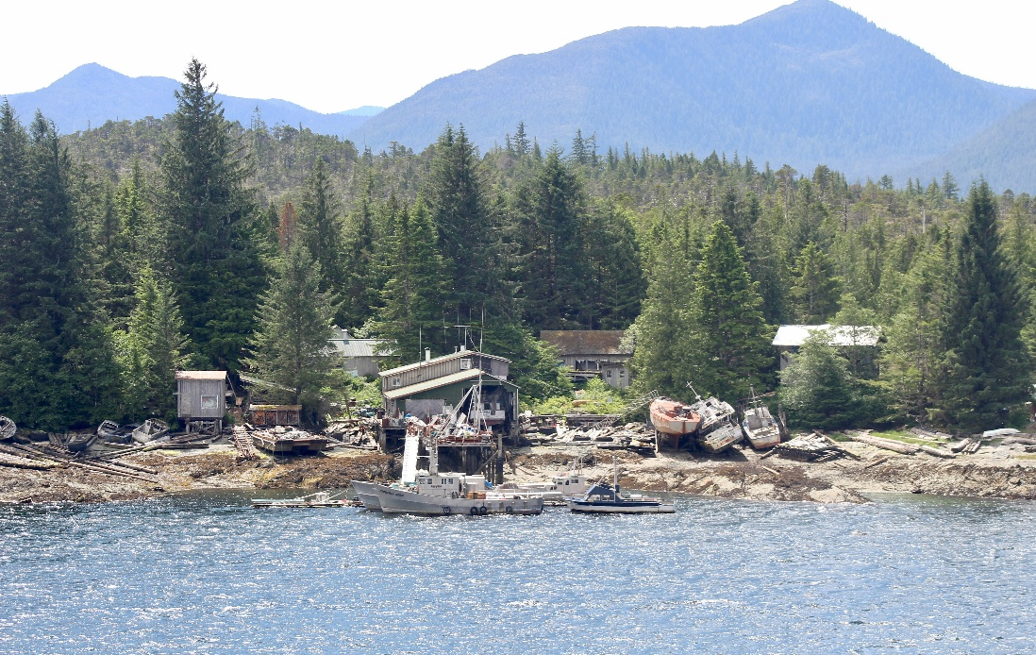

Flood damage from recent GLOF along the Mendenhall River, Juneau: Photo by Lulu Brannan, 2025

According to the USDA Climate Hub, Southeast Alaska is expected to get about 4-6°F warmer by 2050. By 2100, glaciers in this region are expected to shrink by 25-35% of their current size.

Vulnerability Assessment
Climate change affects everyone differently in Juneau. Neighborhoods and communities along the Mendenhall River have been hit especially hard by the 2023 and 2025 flooding from Suicide Basin. In many cases, the damage costs more than what insurance covered, leaving families struggling to recover (USGS, 2025). Residents with fewer resources like low-income households and elderly people struggle the most with both preparation and recovery. Indigenous communities are also deeply affected because they rely on salmon and forest resources for food and cultural traditions. Rising river temperatures, more frequent floods, and the decline of yellow-cedar trees are all making it harder to sustain these practices (USDA Climate Hubs, 2023a).
Unfortunately, Juneau’s infrastructure is constantly under increasing strain due to these conditions. Stormwater systems and flood defenses were never designed for yearly recurring glacial floods. Transportation is already limited and is extremely vulnerable as well. Barriers have been installed to protect threatened communities, but it’s a short-term resolution that is extremely expensive (USGS, 2025). Electricity is another major concern for Juneau because almost all the city’s power comes from hydropower. This system depends on a steady flow of runoff from snow and glaciers. As warming changes when and how fast this runoff occurs, hydropower may become less reliable. This could force changes in how reservoirs are managed and may even require backup energy sources (Cherry et al., 2010).
Tourism is one of Juneau’s main economic drivers, which is ultimately affected by climate change as well. This includes visitors coming to see the Mendenhall Glacier, cruise lines, parks, and many other attractions that are susceptible to flooding. Fishing is also a major part of Juneau’s economy and flooding harms these habitats and marine life. Salmon is especially important, and flooding washes away spawning beds. Water temperatures continue to go up, causing stress on migration patterns. The future of Juneau depends on its environmental stability and climate change is a huge threat.

Current Response Evaluation
In 2011 the city made the Juneau Climate Action and Implementation Plan, setting a goal to cut greenhouse emissions by 25% by 2032. This plan included over 100 ways to be able to make the cut happen. This was an important first step in getting the city to take climate change seriously. As of lately, the flooding from Suicide Basin has been the main concern. USGS and NOAA’s National Weather Service monitor the basin and continue to give updates, as well as warnings. In 2025, the city used Hesco barrier to try and protect over 460 homes (USGS, 2025). Juneau is also currently working on renewable energy programs, but almost all its power comes from hydropower, which cannot be fully dependent on due to climate change.
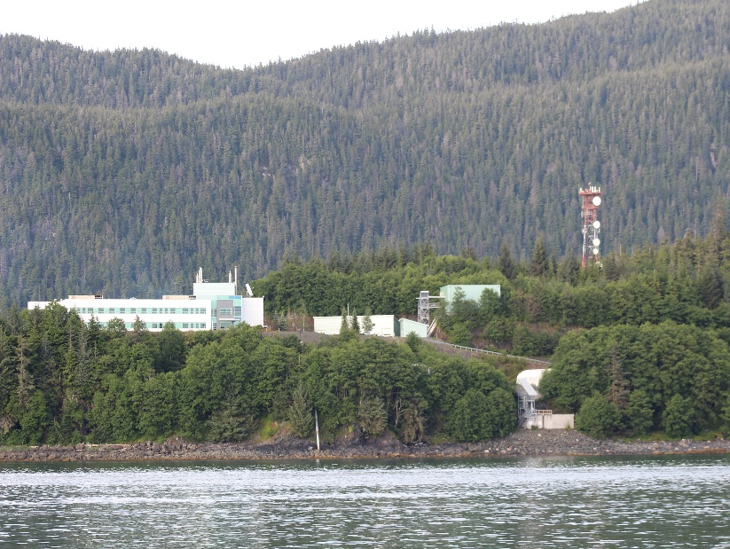
NOAA’s Auke Bay laboratory isn’t just used by NOAA staff. It’s a federal research facility under NOAA’s Alaska Fisheries Science Center, and it works with lots of different groups. These include universities, state agencies, and even tribal organizations. Scientists typically study fish, ocean acidification, marine ecosystems, etc. and how climate change affects them. The National Weather Service in Juneau also helps give forecasts and flood warnings. Although these are steps in the right direction, Juneau still has major gaps in its response. The city needs to update its climate plan to deal with floods, landslides, and other environmental impacts, and the city is left relying on costly short-term fixes. Moving forward, better planning will be needed, as well as support for these effected communities.
NOAA Auke Bay Laboratories facility in Juneau: Photo by Lulu Brannan, 2025
Conclusion
Juneau is already seeing climate change. Suicide Basin floods have forced evacuations and continue to damage Mendenhall River communities, while the Mendenhall Glacier retreat has impacted on the city's water supply and main source of power. Winter is bringing more rain than snow, and landslides endanger roads, homes, and public safety. These are significant changes that influence people's daily lives and highlight Southeast Alaska's rapid climate change.
Setting emissions efficiency goals for the 2011 Climate Action Plan was critical. USGS and NOAA flood data and warnings have helped to prevent catastrophes from glacial outburst floods. Hesco barriers have kept neighborhoods safe from recent floods, despite the cost. Another advantage of Juneau's hydropower dependency is that most residents receive renewable electricity. But the city's long-term threats are not fully addressed.
Juneau will require additional planning and investment for the future. New hydropower management strategies may be required. Glaciers recede, storms worsen, and salmon streams are disrupted, endangering tourism and fishing, two important economic sectors. Low-income families and Indigenous communities recover the slowest after disasters, thus assisting vulnerable neighborhoods is critical.
Juneau's future is dependent on its environment. Climate change is already affecting the environment, and the consequences will only get worse. Whether Juneau chooses short-term solutions or invests in long-term resilience will determine how well it protects its people, economy, and way of life.

Works Cited
“Alaska and a Changing Climate.” USDA Climate Hubs, United States Department of Agriculture, 2023,
https://www.climatehubs.usda.gov/hubs/northwest/topic/alaska-and-changing-climate

Cherry, Jessica E., et al. Impacts of Climate Change and Variability on Hydropower in Southeast Alaska: Planning for a Robust Energy Future. NOAA, 2010,
https://repository.library.noaa.gov/view/noaa/17388.

City and Borough of Juneau. Juneau Climate Action & Implementation Plan. 2011,
https://juneau.org/wp-content/uploads/2017/03/CAP_Final_Nov_14.pdf.

“Southeast Alaska in a Changing Climate.” USDA Climate Hubs, United States Department of Agriculture, 2023,
https://www.climatehubs.usda.gov/hubs/northwest/topic/southeast-alaska-changing-climate.

U.S. Geological Survey. “USGS Measures Glacial Flooding in Juneau, Alaska.” U.S. Geological Survey, 13 Aug. 2025,
https://www.usgs.gov/news/state-news-release/usgs-measures-glacial-flooding-juneau-alaska.

U.S. Geological Survey. “USGS Monitoring of Glacial Outburst Flood in Juneau, Alaska.” U.S. Geological Survey, 5 Aug. 2025,
https://www.usgs.gov/centers/alaska-science-center/news/science-spotlight-usgs-monitoring-glacial-outburst-flood-juneau.

