Lulu Brannan
Dr. Yao
GHY4812-102
04 May 2026

Coastal Suitability Analysis for Oyster Reef Placement Along Topsail Island, North Carolina

Background and Introduction
Coastal erosion is a major issue along barrier islands such as Topsail Island, North Carolina. Barrier islands are naturally dynamic landforms that are constantly shaped by wave action, storms, tides, and sediment movement. Over time, these coastal processes can lead to shoreline instability, land loss, and increased vulnerability for both natural ecosystems and human development. As coastal populations continue to grow and development increases along the shoreline, the impacts of erosion become more significant. Homes, businesses, roads, and public infrastructure are increasingly threatened by erosion and storm impacts, making coastal protection and long-term planning extremely important.
Communities along the North Carolina coast have used multiple methods to reduce erosion, including beach nourishment through dredging and the use of sandbags. Beach nourishment temporarily restores eroded shorelines by adding sand back onto beaches, but these projects are often expensive and require repeated maintenance over time. Sandbags are another commonly used protection method, although they are generally considered a short-term solution because they can shift, fail during storms, and negatively impact the natural appearance of the coastline. Due to the limitations of these traditional approaches, there has been growing interest in more sustainable and environmentally beneficial coastal protection strategies (NOAA, 2024).
One potential solution is the use of oyster reefs. Oyster reefs act as natural barriers that help absorb wave energy, stabilize sediments, and improve coastal resilience while also supporting marine ecosystems (Scyphers et al., 2011; NOAA, 2024). However, oyster reefs are not equally effective in every location. Their success depends on environmental conditions such as exposure, terrain stability, and proximity to the shoreline. Because of this, identifying the most suitable locations for reef placement is an important part of effective coastal management.
The purpose of this project is to identify suitable locations for oyster reef placement along Topsail Island using GIS-based spatial analysis. This project focuses on two physical variables that directly influence erosion risk and stability: distance from the coastline and slope. By combining these variables into a suitability model, this analysis identifies areas that are more vulnerable to erosion as well as areas that are more stable and potentially better suited for coastal protection strategies.
Barrier islands such as Topsail Island are especially sensitive to environmental change because they are constantly influenced by coastal forces. As sea-level rise and stronger storm events continue to impact coastal communities, the need for effective and sustainable shoreline protection becomes increasingly important. Traditional approaches such as dredging and sandbags often provide only temporary protection and may require repeated maintenance over time. Because of this, many coastal communities have started exploring more natural and long-term approaches to erosion reduction (NOAA, 2024).
GIS provides an effective way to analyze environmental conditions spatially and identify areas where these strategies may be most successful. By using GIS-based suitability analysis, it is possible to evaluate multiple variables at once and better understand how physical conditions vary throughout the landscape. This allows for more informed planning decisions and helps identify locations where coastal protection efforts may provide the greatest benefit.

Study Area and Data Collection
The study area for this project is Topsail Island, located along the southeastern coast of North Carolina. Topsail Island is a narrow barrier island approximately 26 miles long and is divided into the communities of North Topsail Beach, Surf City, and Topsail Beach. The island is highly vulnerable to coastal processes such as storm surge, wave action, erosion, and shifting sediment patterns. Due to its exposure to hurricanes and coastal storms, Topsail Island experiences ongoing shoreline change and is an appropriate location for evaluating coastal protection suitability.
Two primary datasets were used in this analysis: distance from the coastline and slope. Distance from the coastline was used to represent exposure to coastal processes. Areas located closer to the coastline are generally more exposed to wave action and erosion, while areas farther inland are typically more stable and protected. Slope was used to evaluate terrain stability across the island. Areas with steeper slopes are generally more prone to instability and erosion, while flatter areas are considered more stable and suitable for long-term coastal protection efforts.
The data used in this project was obtained from publicly available GIS sources. Elevation data was collected from the United States Geological Survey (USGS) National Map database, while coastal boundary datasets were obtained through Natural Earth vector data. Additional land cover information was accessed through the Multi-Resolution Land Characteristics Consortium (MRLC) National Land Cover Database (NLCD). These datasets were processed and analyzed using ArcGIS Pro.
Topsail Island was selected for this project because it represents a highly dynamic coastal environment that experiences ongoing shoreline change and storm impacts. The island’s narrow shape and direct exposure to the Atlantic Ocean make it particularly vulnerable to erosion. In addition, the island contains both developed and undeveloped areas, allowing for variation in environmental conditions throughout the study area. These characteristics make Topsail Island an appropriate location for conducting a GIS-based suitability analysis focused on coastal protection and stability.

Figure 1. Distance from Coastline Map
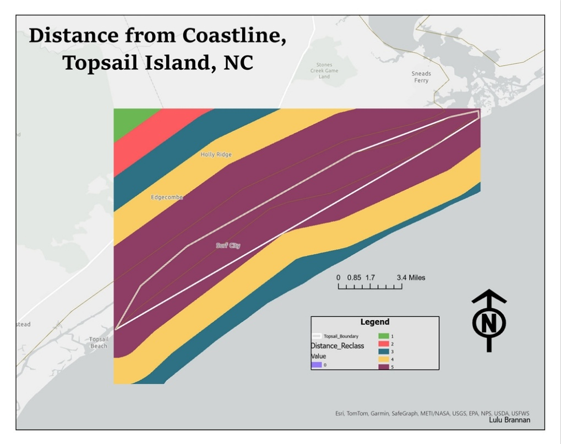

Figure 2. Slope Analysis Map
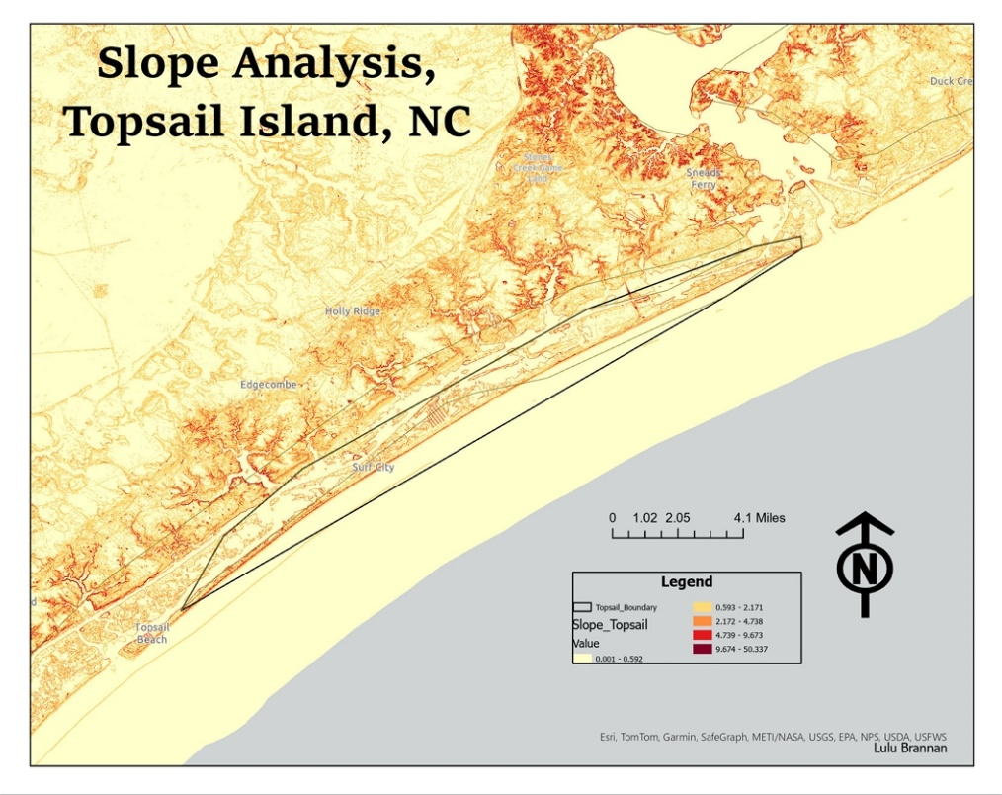

Methods
This project used a raster-based GIS suitability analysis in ArcGIS Pro to evaluate environmental conditions across Topsail Island (Esri, 2024). The analysis focused on combining multiple environmental variables to identify areas that are more or less suitable for coastal protection strategies such as oyster reef placement.
The first step involved preparing the data layers used in the analysis. Elevation data from the digital elevation model (DEM) was used to calculate slope across the island using the Slope tool in ArcGIS Pro. This produced a raster layer representing terrain steepness throughout the study area. A second raster layer was created to represent distance from the coastline. This layer was used to measure exposure to coastal processes such as wave energy and erosion.
After the datasets were prepared, both raster layers were reclassified into a common suitability scale ranging from low suitability to high suitability. Reclassification was necessary because the original datasets contained different value ranges and measurement units. By standardizing the data, both variables could be compared consistently and combined into a single suitability model. Higher suitability values represented flatter and more stable areas, while lower values represented locations that were more exposed to erosion and instability.
Once both layers were reclassified, the Raster Calculator tool was used to combine the slope and distance datasets into a final suitability raster. This process allowed multiple environmental factors to be analyzed together instead of separately. The resulting suitability map grouped areas into low, moderate, and high suitability categories.
Raster-based analysis was selected for this project because it allows environmental variables to be analyzed continuously across space rather than as isolated points or features. This makes raster analysis especially useful for suitability modeling because environmental conditions often vary gradually across a landscape. Reclassifying the datasets into a common scale simplified the comparison process and allowed both variables to contribute equally to the final suitability model.
The use of Raster Calculator also made it possible to combine multiple variables into a single output layer. This approach provides a clearer understanding of how environmental conditions interact spatially rather than evaluating each variable separately. Overall, the workflow used in this project demonstrates how GIS analysis techniques can be applied to real-world environmental and planning problems.

Results and Discussion
The results of the analysis demonstrate that suitability for coastal protection varies across Topsail Island. The distance from coastline map showed that areas closer to the shoreline are more exposed to coastal processes and are therefore less stable. Areas located farther inland generally showed higher suitability due to reduced exposure to wave action and erosion.
The slope analysis produced similar patterns. Areas with steeper slopes were identified as less stable and more prone to erosion, while flatter areas were considered more suitable for coastal protection efforts. Since barrier islands are relatively low and flat environments overall, subtle changes in slope still played an important role in identifying stable versus unstable areas.
The final suitability map combined both variables into a single model that identified areas of low, moderate, and high suitability across the island. Higher suitability areas were concentrated through the more interior portions of the island, while lower suitability areas were located closer to the outer shoreline edges. Areas near the coastline are more exposed to wave action, storm surge, and erosion processes, making them less stable over time. In contrast, interior portions of the island generally displayed more stable conditions within the model results.
These results support the project objective of identifying erosion-prone zones and more stable areas for potential oyster reef placement. Areas classified as low suitability represent locations that are more vulnerable to erosion and may require greater attention in future coastal management efforts. Areas with higher suitability values may provide better long-term conditions for oyster reef placement and shoreline stabilization.
The final suitability map also demonstrates that environmental conditions are not uniform across Topsail Island. Instead, stability and erosion risk vary spatially depending on terrain and proximity to the coastline. This highlights the importance of site-specific analysis when planning coastal protection strategies. Applying the same protection method uniformly across the island may not be effective because some areas are significantly more vulnerable than others.
The results also support the idea that GIS suitability modeling can assist decision-making by identifying patterns that may not be immediately visible otherwise. By combining multiple datasets into a single model, the analysis provides a more comprehensive understanding of environmental conditions throughout the island. This type of spatial analysis can help planners and decision-makers prioritize areas for future protection efforts and environmental management (Esri, 2024).
One limitation of this analysis is that some portions of the raster suitability layers extend slightly beyond the physical land boundary of Topsail Island and into surrounding water areas. This is likely related to raster cell resolution, generalized coastline geometry, and the narrow shape of Topsail Island as a barrier island. Because raster datasets are composed of square grid cells, the analysis extent does not always align perfectly with irregular coastal boundaries. Despite this minor visual offset, the overall spatial patterns and suitability results remain consistent and effective for identifying relative differences in stability and coastal exposure across the island.
One additional limitation of this study is that the analysis only included two variables: slope and distance from the coastline. Other important environmental factors such as vegetation, wave dynamics, sediment composition, tidal influence, and land cover were not included in the final model. Including additional datasets could improve the accuracy and complexity of the suitability analysis. Additionally, barrier island environments are highly dynamic and constantly changing, meaning that suitability conditions may shift over time due to storms, sea-level rise, and erosion.

Figure 3. Final Suitability Analysis Map
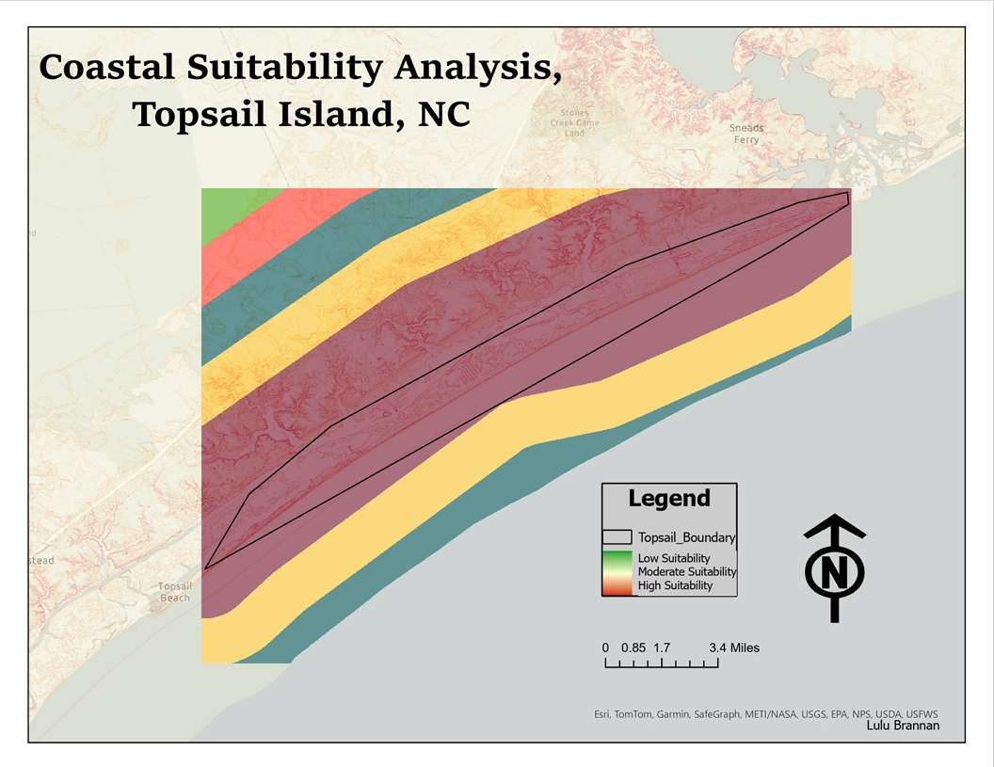
Despite these limitations, this analysis demonstrates how GIS can effectively support coastal planning and environmental decision-making by identifying spatial patterns of stability and erosion risk.

Conclusion
This project demonstrates how GIS-based suitability analysis can be used to identify appropriate locations for coastal protection strategies along Topsail Island, North Carolina. By combining slope and distance from the coastline into a raster suitability model, the analysis successfully identified both erosion-prone areas and more stable locations across the island.
The results show that suitability varies spatially throughout Topsail Island, with lower suitability areas concentrated near highly exposed coastal zones and higher suitability areas occurring in flatter and more stable locations. These findings highlight the importance of using spatial analysis to support more targeted and informed coastal management decisions rather than applying protection strategies uniformly across the landscape.
Overall, this project demonstrates the usefulness of GIS as a tool for environmental analysis and coastal planning. Suitability modeling provides a practical approach for evaluating environmental conditions and identifying areas where future coastal protection efforts, such as oyster reef placement, may be most effective.
In addition to identifying suitable areas for oyster reef placement, this project also demonstrates the broader value of GIS in coastal planning and environmental analysis. Spatial modeling allows environmental variables to be evaluated together in a way that improves understanding of geographic patterns and relationships. As coastal communities continue to face increasing environmental challenges, GIS-based analysis will likely become an even more important tool for supporting sustainable planning and management decisions in the future.

Works Cited

Esri. (2024). ArcGIS Pro Documentation. Retrieved from https://pro.arcgis.com/

MRLC. (2024). National Land Cover Database. Retrieved from https://www.mrlc.gov/data

Natural Earth. (2024). Natural Earth Vector Data. Retrieved from https://www.naturalearthdata.com/

NOAA. (2024). Digital Coast. Retrieved from https://coast.noaa.gov/
Scyphers, S. B., Powers, S. P., Heck, K. L., & Byron, D. (2011). Oyster reefs as natural breakwaters mitigate shoreline loss and facilitate fisheries. PLoS ONE, 6(8), 1–8.

USGS. (2024). The National Map. Retrieved from https://apps.nationalmap.gov/downloader/

